Discrete Math’s

Submitted to: Dr. Aladeen Al Basheer

Submitted by: Yousef Abu Ali

Assignment 1 Take home

Proving the five-color theorem

**Take home assignment (Part 1 – Task 1):**

Construct a proof of the five-color theorem:

Introduction:

The Graph coloring is an important part of graph theory, it works on giving a color for each Node in a graph in a way were no two Nodes that are connected to each other (Adjacent Nodes) have the same color. And the main goal is to use as few colors as possible while making sure to satisfy that constraint. (GeeksforGeeks, 2017)

A Planer graph is graph that is drawn on a flat surface, such as a piece of paper. And a graph is considered a planner graph if it could be drawn without any edges crossing each other.

The Five-Color theorem:

The theorem indicates that any simple planner graph can be colored with five colors at most.

I will prove this theorem using the technique of mathematical induction.

Let’s consider a vertex V with a degree of five or less (Deg(V) <=5).

Starting with the Base Case: our simple case is that we could have a graph with a single node(vertex). Therefore, we would just choose one color for that node, and it will be over.

Now there will be no problem with graphs with five nodes or less, as each vertex could be given a unique color.

For example:

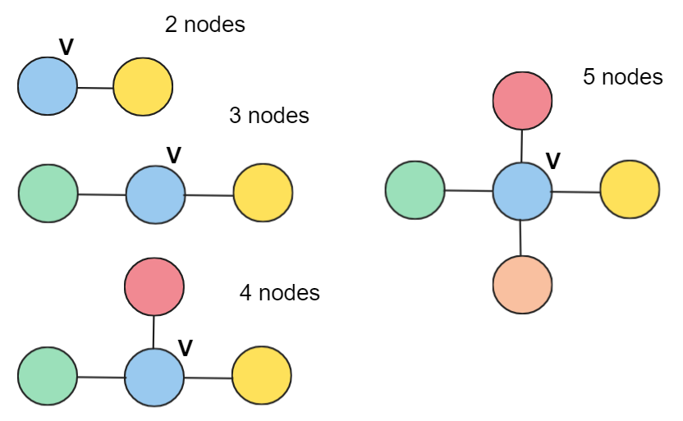

Now what if the vertex (V) is connected to five other Nodes(vertices) by edges. Therefore, we are assuming that the vertex V has a degree of exactly five.

Deg(V)=5

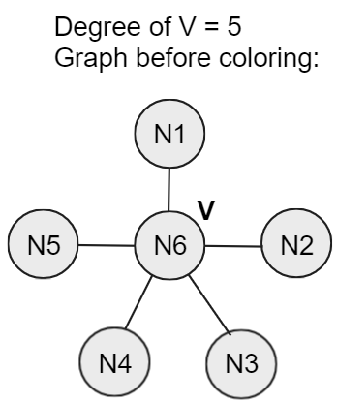

Now we will assign a color for each node other than V ( I will leave V uncolored). Therefore, all the Nodes (N1 🡪 N5) will have used one of the five colors that we have (thus using the five colors).

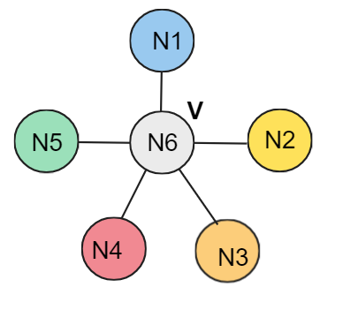

After we have assigned all colors to the other nodes, there are no colors left for Node V. Therefore, we will have to change some of the colors around V (N6) in order to be able to color V.

Let’s suppose that there is a path between nodes N1 and N3, for example N1🡪 a 🡪 b 🡪c 🡪d🡪N3:

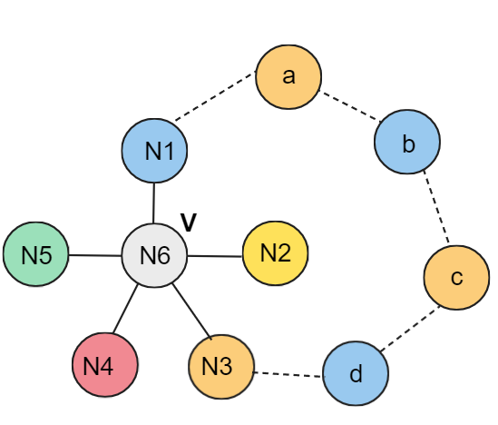

Now there will be no benefit of switching the colors between the nodes N1 to N2 as we will not solve the problem, we will just end up with the same thing except changing the position of colors:

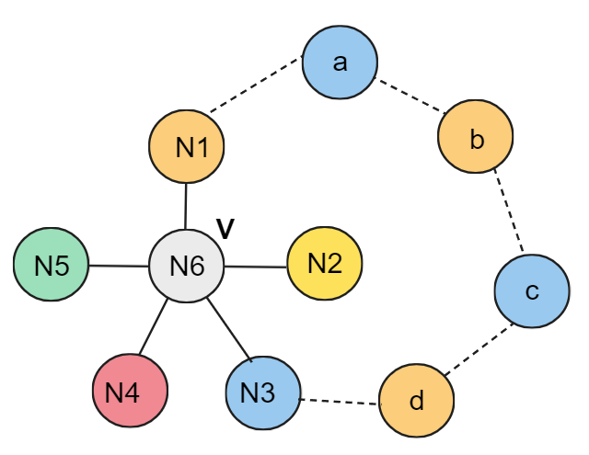

But the benefit comes here from the property of the planer graph, there will be no bath between node N2 and node N4 ( because it will intersect the path N1 and N3). The path N1 🡪 N3 has created a wall of separation between N2 and N4 ( also with N5 but N4 is for example).

So, the N4 (red) could be connected to a yellow node, and that yellow node with another red node, and so on. Also, N2 could be connected with a red node, and that red node with another yellow node, and so on. But that chain (path) N4 will never be connected with the yellow-red chain (path) inside that wall (N2) :

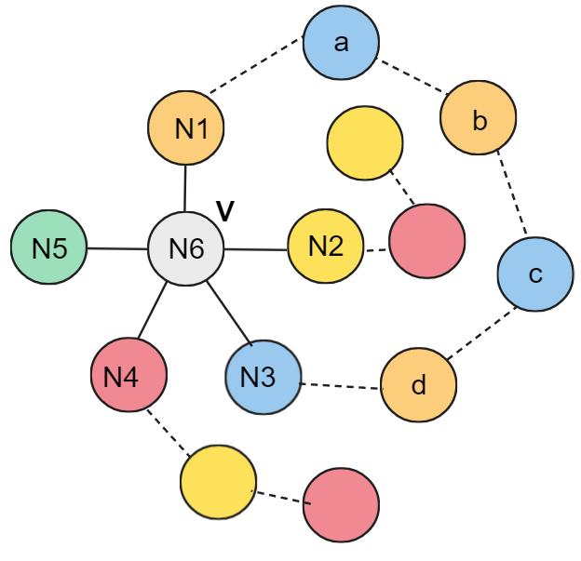

And there is no way to connect the red-yellow chain outside the wall (N4) with the yellow-red chain (N2) inside the wall (the blue-orange barrier N1 🡪 N3).

Therefore, now we can freely switch the reds and yellows in one of the chains, for example the inside chain (N2):

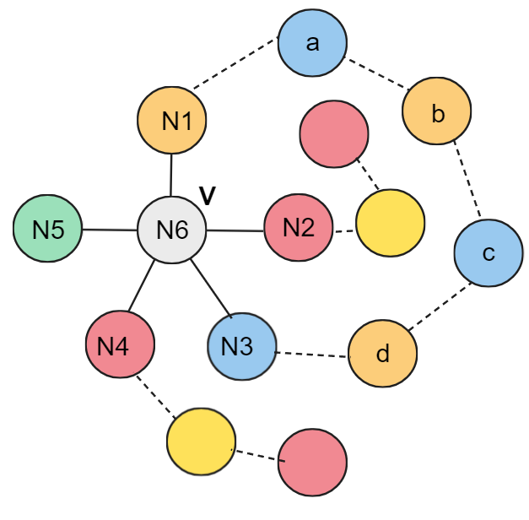

As a result, we have now freed yellow from being used. Which gives us the ability to color the center (V , N6) with yellow.

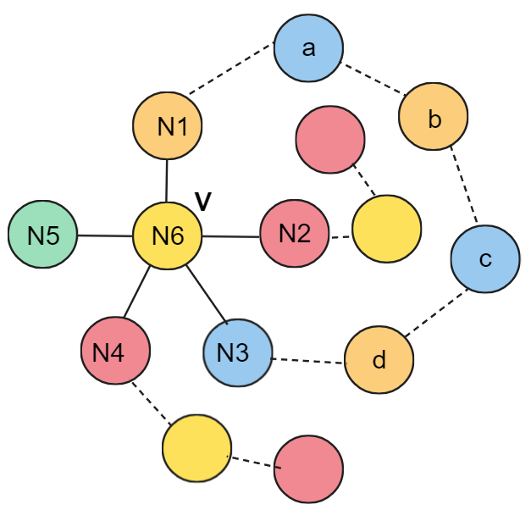

What the five color theorem shows is that there is always a way to color a map in a way that at most five colors are used.

References:

1. GeeksforGeeks. (2017). Mathematics | Planar Graphs and Graph Coloring. [online] Available at: <https://www.geeksforgeeks.org/mathematics-planar-graphs-graph-coloring/>.
2. Carter, T. (2017). The 5 Color Theorem. [online] Available at: <https://csustan.csustan.edu/~tom/Lecture-Notes/5-colors/5-color.pdf>.
3. Math at Andrews (2020). Graph Theory 7: Five Color Theorem. YouTube. Available at: <https://www.youtube.com/watch?v=5mdH0UeBaR0>.
4. GeeksforGeeks. (2023). 5 Color Theorem in Graph Theory. [online] Available at: <https://www.geeksforgeeks.org/5-color-theorem-in-graph-theory/>.